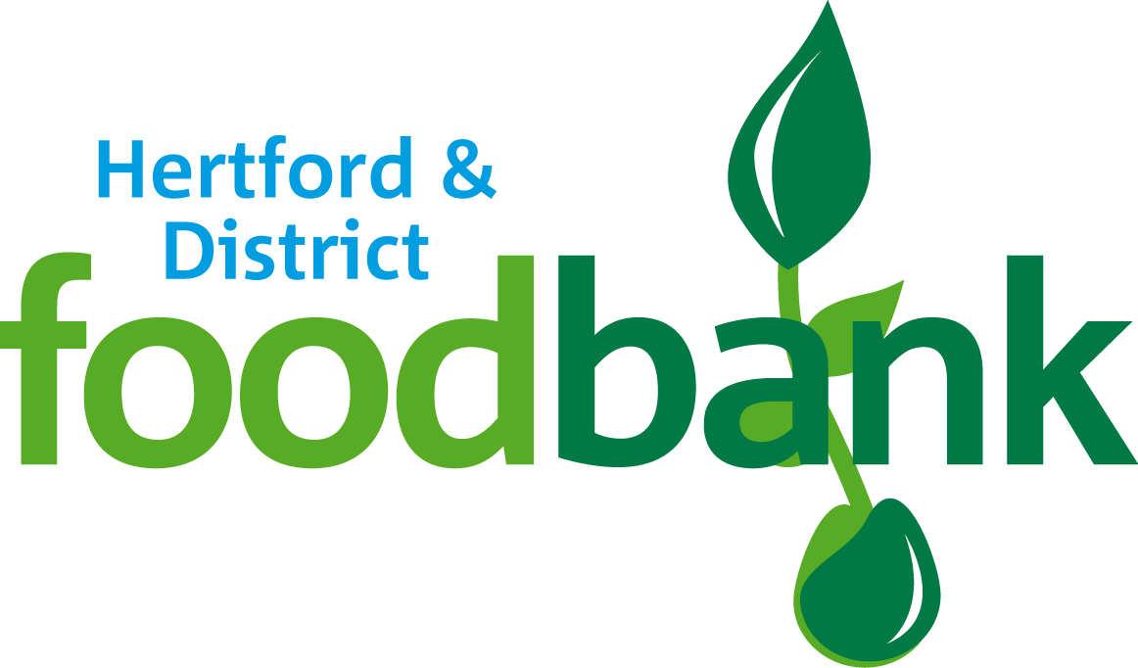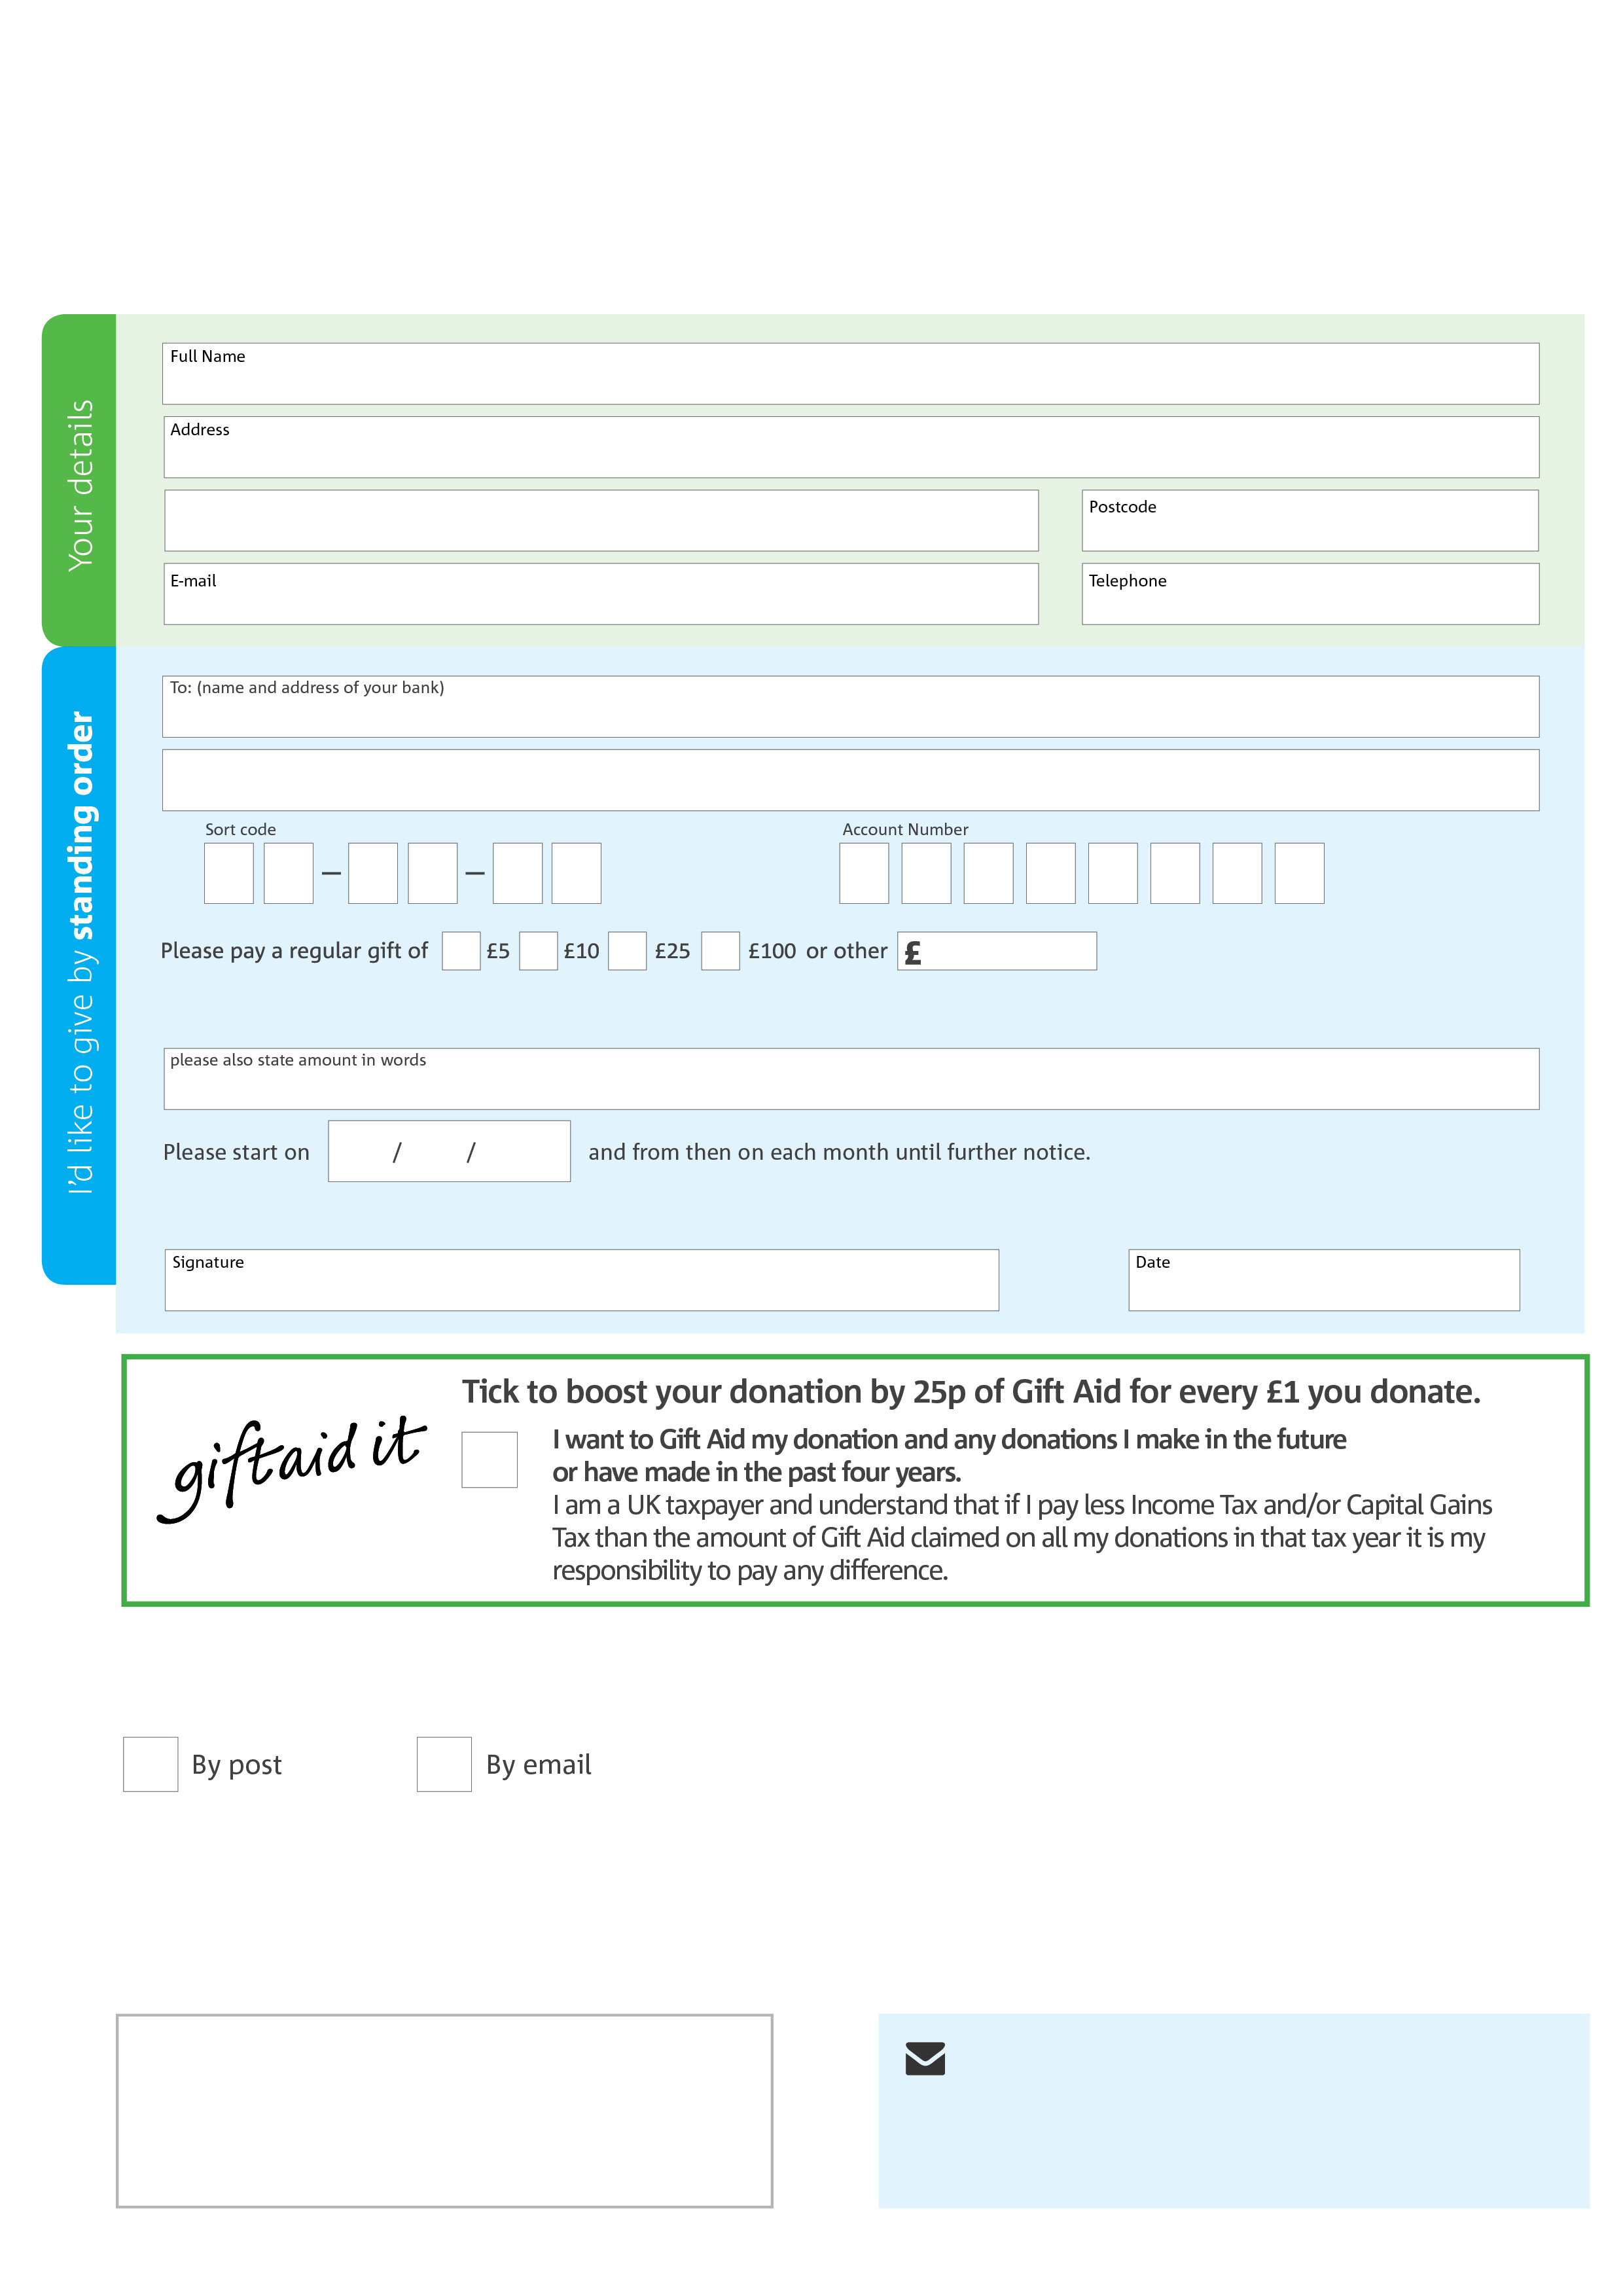­

**Please send your completed form to:**

Colin Bird, Hertford & District Foodbank

United Reformed Church  
Cowbridge,   
Hertford,   
SG14 1PG

Reg. Charity No: 1157028 Reg. in England & Wales

**Data protection**

Hertford & District Foodbank is committed to protecting your privacy and will process your personal data in accordance with current Data Protection legislation. Hertford & District Foodbank will never sell or pass your details onto anyone. A full data privacy statement for financial donors is available from the foodbank on request.

**We would love to keep in touch with you so we can update you on our work. You can change your preferences any time by contacting us on 07851 708470 or emailing us at info@hertforddistrict.foodbank.org.uk**

**Please tick here if you would be happy to receive communications from us:**

**Hertford & District Foodbank’s bank details:**

Bank: **HSBC**

Account name: Hertford & District Foodbank

Sort code: 40-24-13

Account number: 91631977

This cancels any previous standing order instructions to Hertford & District Foodbank

To Hertford & District Foodbank each month,

hertforddistrict.foodbank.org.uk