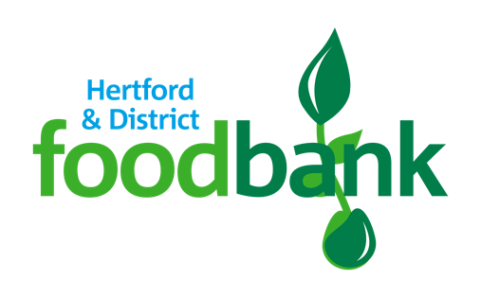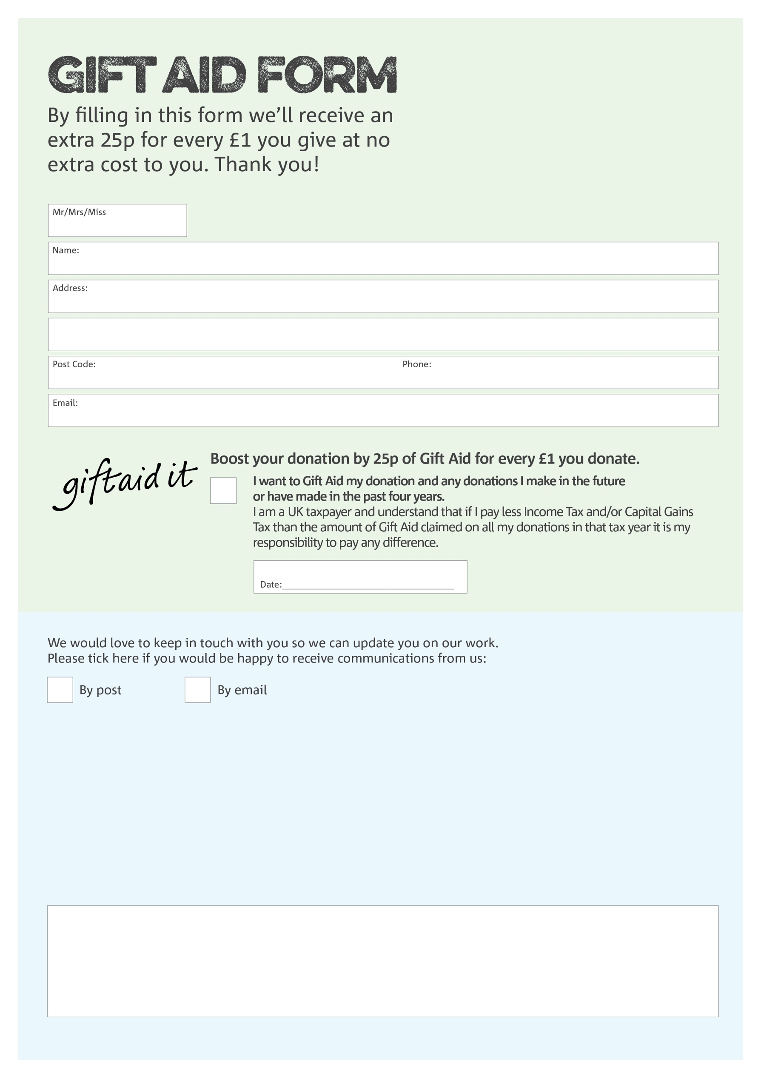

**Data Protection**

Hertford & District Foodbank is committed to protecting your privacy and will process your personal data in accordance with current Data Protection legislation. Hertford & District Foodbank will never sell or pass your details onto anyone. A full data privacy statement for financial donors is available from the foodbank on request.

You can change your preferences any time by contacting us on 07851 708470 or emailing us at

info@hertforddistrict.foodbank.org.uk

We would love to know why you have chosen to donate to Hertford & District Foodbank. If you would like to share your motivation let us know below:

Charity Number 1157028. Registered in England & Wales